John Michael Go
Career Entry Level Java Programming
Date: Jan. 22, 2013

DAY 8

Program Name: Array6

Objective: Program that sorts an integer array.

Algorithm:

1.Program sorts integers in an array.

Flowchart:

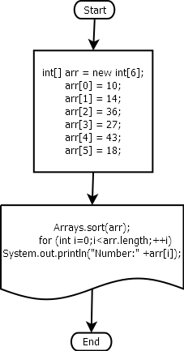

Pseudocode:

public class Array6 {

public static void main(String[] args) {

int[] arr = new int[6];

arr[0] = 10;
arr[1] = 14;
arr[2] = 36;
arr[3] = 27;
arr[4] = 43;
arr[5] = 18;

Arrays.sort(arr);
for (int i=0;i<arr.length;++i)
System.out.println("Number:" +arr[i]);
}

}

Screenshots:

